Name: Mariel Joy A. Casicas
Year & Sec: 3rd - B

“Individual Activity4: “Design Your Own System Using UML”

Part 1: System Idea & Recall
- Four UML Diagrams.
- Use Case Diagram – Shows the users of the system and what actions they can do. It helps identify the main functions of the system.
- Activity Diagram – Shows the step-by-step flow of a process. It is useful for understanding how the system works from start to finish.
- Class Diagram – Shows the classes, attributes, methods, and relationships in the system. It helps describe the structure of the system.
- Sequence Diagram – Shows how users and system parts interact with each other in order. It focuses on the flow of messages or actions.
- System Title.
“Barangay Document Request System”

Short Description
The Barangay Document Request System is a simple application that allows residents to request barangay documents online. Residents can submit requests for documents such as Barangay Clearance, Certificate of Residency, and Certificate of Indigency. The barangay staff can view, process, and update the status of each request. This system helps reduce long lines and makes document processing faster and more organized.
Main Features:
- Resident registration and login
- Submit document request
- View request status
- Barangay staff approval and processing
- Notification for completed request

Part 2: UML Diagram Creation
- Use Case Diagram.
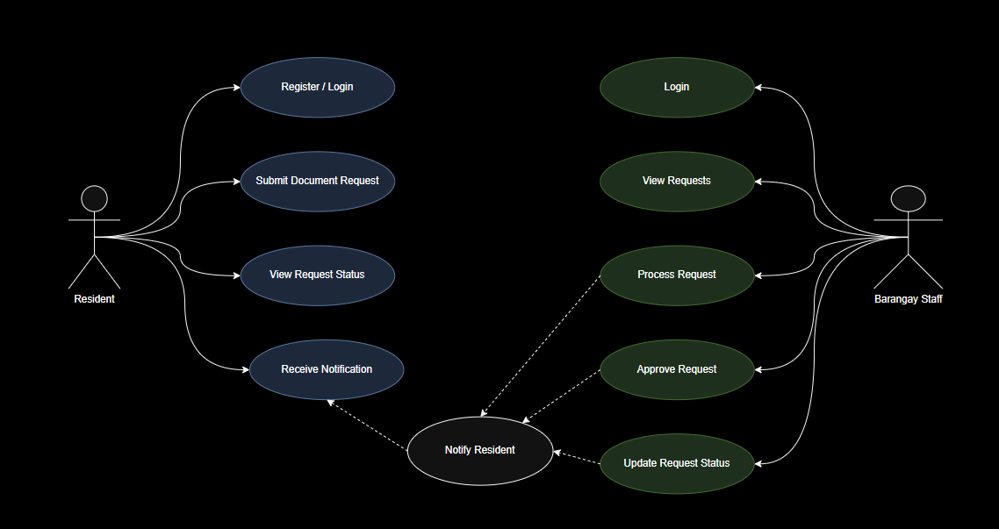

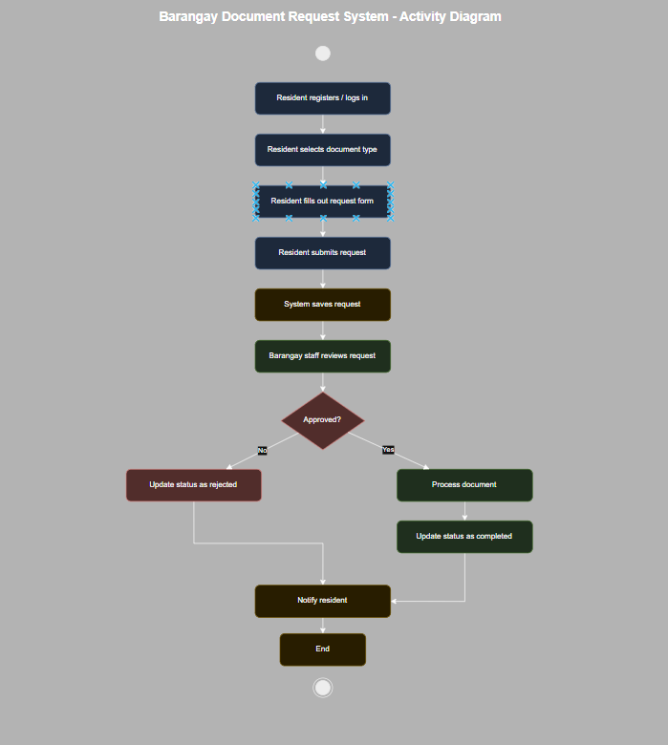
- Activity Diagram.

Part 3: SDLC Application
Planning:
In the planning phase, the purpose of the Barangay Document Request System is identified. The needed features, users, and documents to be requested are planned.
Design:
In the design phase, UML diagrams are created to show how the system will work. The layout, process flow, and database structure are also planned.
Implementation:
In the implementation phase, the system is developed using programming tools. Features such as resident login, document request submission, and staff processing are created.
Testing:
In the testing phase, the system is checked to make sure it works properly. The login, request submission, status update, and notification features are tested for errors.
Part 4: Reflection
- What did you learn from creating UML diagrams?

I learned that UML diagrams help explain the functions and flow of a system clearly. They make it easier to understand how users and the system interact before development starts.

- Why is planning important before building a system?

Planning is important because it helps identify the system requirements and possible problems early. It also guides the developer in building the system correctly and efficiently.

